Workshop 1
1.
- Task 1.1: Play and explain (in your own words) the Game Called ‘Observation and Approximation’ for Dependent (a) and Independent (b) variables:
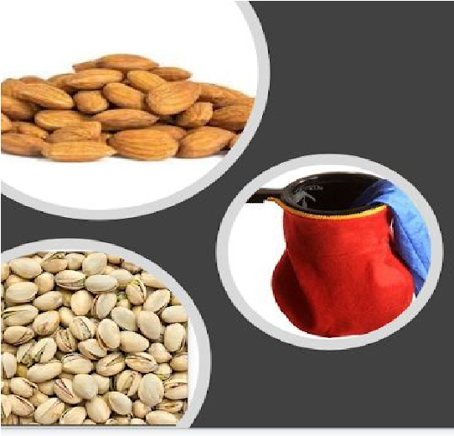
  - Suppose that without your knowledge, XXX Almonds and YYY Pistachios are hidden in a bag. How can we determine the ratio of Almonds versus Pistachio? By experiment, draw one nut after another (with the replacement of the drawn). Note how many times an Almond is drawn versus Pistachio. You will see, as the number of trials will increase, the expected value of Almond versus Pistachio will converge on the actual ratio, known as the weak law of large numbers.
  - Now, we assume having two states: (1) 50-50 mix of Almonds versus Pistachios (2) More Pistachio versus Almond (we don’t know how many more, just random). One State is called State ‘A​ ’​ that represents a Almond having previously occurred, and the other, we call State ‘P​ ’​ that represents a Pistachio having previously occurred. Start a game and make a random selection from the two states (i.e. draw one nut randomly). Place it back, and move to either state A​ or P​ ,​ depending on the last event. With this two-state machine, we can identify four possible transitions. As the number of trials increases and N-->infinity​ ,​ the number of times you visit each state converges to some specific ratio or a probability.
- Task 1.2: Explain the difference between a and b?​
Solution a is a random sampling technique, which as the number of samples gets higher, accuracy also increases and we expect it to converge for a large enough number of samples N. Solution b, uses a two-state machine and at each sampling step, it moves from one state to another. Eventually for a large enough number of samples N’ it will converge to a good approximation. Personally, I believe, both techniques are similar, with random sampling being easier to implement. The number of samples that I would expect each technique to converge should be very similar ie. N ≈ N’.
- Task 1.3: Find the following percentages for 10 trials.
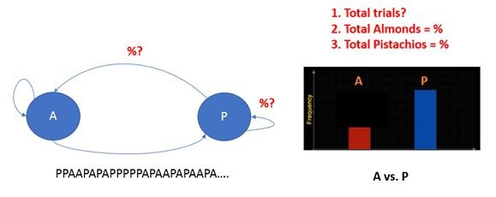

- Total trials = 10
- Total Almonds = 4
- Total Pistachios = 6
So, 40% almonds and 60% Pistachios

2. Task 2: Simplified weather prediction model using Markov Chain
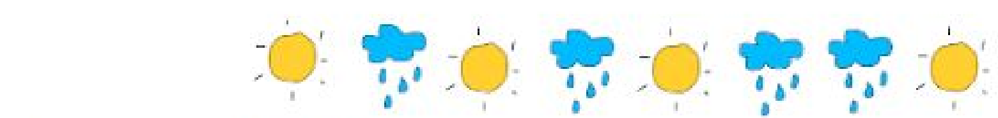
- Dataset = {SRSRSRRS}
- Initial state: X0​ = [1 0] i.e. The weather today is known to be sunny.​
i. Transition matrix: T = [? ?; ? ?] ii. Weather condition on day 10th? iii. Weather condition on day 20th? iv. Weather condition on day 1000th?
  - Weather condition on day 100000th (far in future)?
  - What is the difference among ii, iii, iv, and v?
  - If we continue to increase the number of trails (e.g. n-->infinity), what will happen?

3. Task 3: Code Task 2

